**Fractions, Decimals and Percents.**

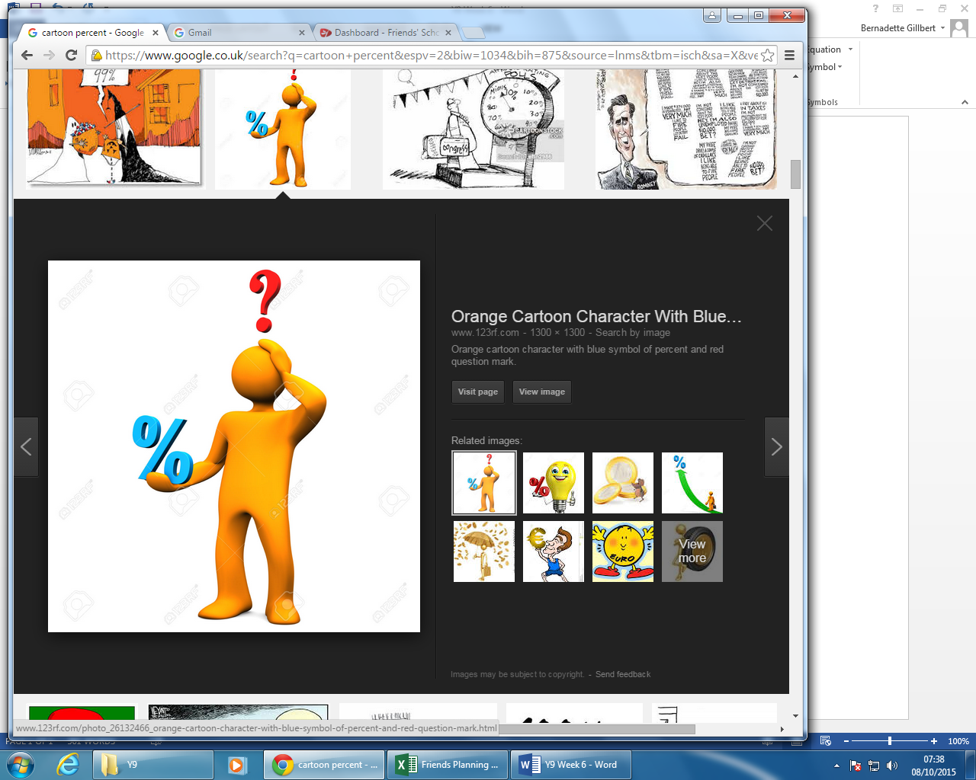**Comparing Proportions** – If you have lots of information and some of it is in fractions, some in percent and some in decimals, the easiest way to compare is to convert them all to the same type of number.

**To change a Fraction to a Percent**: Equate the fraction so that the denominator is a multiple of 10, then use this to make the denominator a multiple of 100 (it may stop the numerator from being a whole number, but this doesn’t matter). Then, add “%” after your numerator and remove the denominator.

**To change a Fraction to a Decimal**: Equate the fraction so that the denominator is a multiple of 10, then use this to make the denominator a multiple of 100 (it may stop the numerator from being a whole number, but this doesn’t matter). Then move your numerator’s decimal place 2 places to the right and remove the denominator.

**To change a Percent to a Fraction**: remove the “%” sign, and write your percent over 100. Simplify if you can.

**To change a Decimal to a Fraction**: move your decimal place 2 places left, and write the decimal over 100. Simplify if you can.

**To change a Decimal to a Percent:** multiply your decimal by 100 (move the decimal place 2 places to the right) and add a “%” sign.

**To change a Percent to a Decimal:** Remove the “%” sign, and divide by 100 (move the decimal place 2 places to the left).

The easiest way to find a Percentage or Decimal of a number, without a calculator, is to change your Perecentage or Decimal, into a fraction, and then multiply.

E.g. 30% of 200. 30% = 30/100 = 3/10. 200 x 3/10 = 600/10 = 60

**Percentage Change: Multiplier!**

To find the Percentage change of a number, you need to take = new percentage. The difference between this and 100, is your increase / decrease in percent.

To change a number by a set percentage, you need to find the multipler. This is = multiplier, which will be a decimal. You then MULTIPLY your old number by this.

**A Fraction** is any two numbers, with one written over the other. They signigfy THE AMOUNT OF A WHOLE that you have.

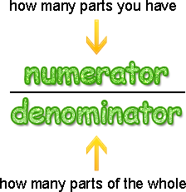**Equivalent Fractions** – Are 2 fractions which are the same amount, but written in different ways. Such as ½ and 2/4.

We can change fractions to their equivelents by MULTIPLYING THE NUMERATOR AND THE DENOMINATOR BY THE SAME AMOUNT.

E.g. 4/7 is equivelent to…. (multiply the top and bottom by 6) … 24/ 42.

**Adding and Subtracting Fractions** – You can add any two fractions (or subtract any two fractions) if they have the same denominator. So you must: find an equivalent fraction to the one in the question so that both fractions have the same denominators, and then add the numerators.

e.g. 4/8 + 2/6  I know that 24 is in both the 6 and 8 times table. So I want a denominator of 24. (8x3 = 24) so I multiply the top and bottom of the first fraction by 3. (6 x 4 = 24) so I multiply the top and bottom of the second fraction by 4.

I get: 12/24 + 8/24 = 20/24… I can then simplify down to another equivelent fraction…. 20/24 = 10/12 = **5/6.**

**Multiplying Fractions –** Multipying Fractions is far easier, you just need to multiply the tops together, and the bottoms…

e.g. 5/6 x ¾ = (5 x 3)/(6 x 4) = 15/24 And Simplify…. 5/8

**Dividing by a Fraction –** To divide by a Fraction, you need to TURN THE SECOND FRACTION UPSIDE DOWN… and switch the sign to a multiplying sign. Then you can solve exactly as you do for multiplying fractions.

e.g. 6/9 ÷ 5/7 = 6/9 x 12/5 = (6x7)/(9x5) = 42/45